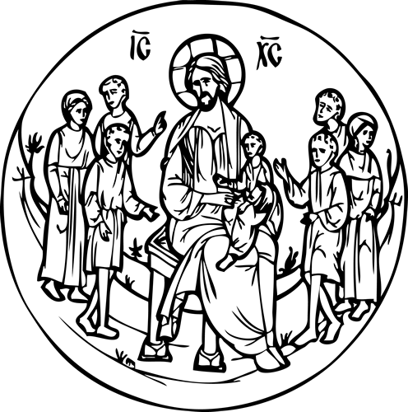
St. George Byzantine Catholic Church
1001 Clinton Street
Aliquippa, PA 15001
www.stgeorgebyzantinecatholicchurch.org

2018
Vacation Bible School
“All Things Byzantine II”
July 17 – 20 (Tue. – Fri.) from 9:00 AM to 12:30 PM
Our VBS week will kick –off on Sunday, July 15 with Sundae Sunday following Divine Liturgy. There will be an at home activity on Monday, July 16 to get ready for the week (Attached). We will then gather from July 17 - 21 for a VBS Journey on the spacious grounds and church hall of St. George Byzantine Catholic Church.
The week will include walking the prayer path, learning to chant, crafts, games, blessing of bicycles, Liturgy, lunch, and more! The VBS Journey will take place 9:00 AM to 12:30 PM daily. The children should bring a medium sized basket with them which will be filled to make a learning basket to take home. Lunch will be served.
Registration by email at jhbyz@comcast.net or call Jo Ann at 724-375-7790
----------------------------------------------------------------------------------------------------------------------------
Please bring this completed form on the first day

Child’s Name _____________________________________________________
Parent/Guardian Name(s) ___________________________________________
Address ________________________________________________________
Phone _________________________ Email___________________________
Emergency Number (During time and dates of VBS) _________________________________
BBQ
Learn to
Chant
Crafts

